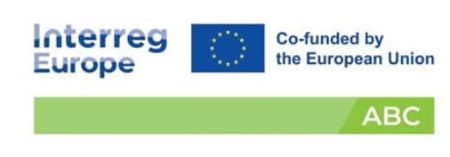
Korça Region:
A Quick Scan of Crops, Carbon Landscapes, and Regenerative Biomass Potential

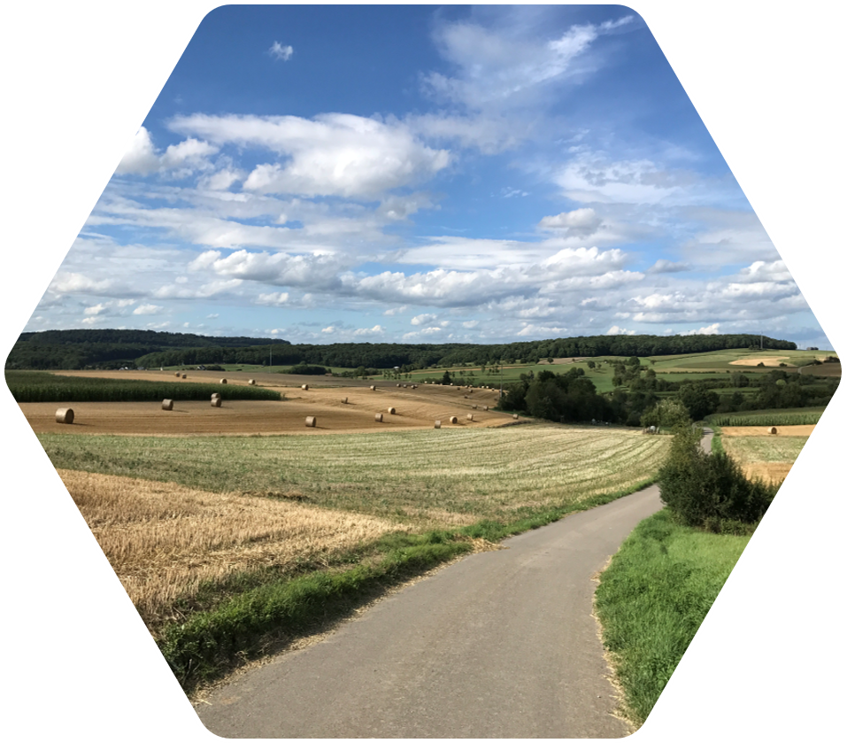

Table of Contents
1. Introduction 6
1.1 ABC Project Summary: Quantifying Carbon Removal with Farm‑Sourced Building Materials 6
1.2 Executive Summary 7
1.3 Introduction on agro-building concept and Objectives 9
1.3.1 Background 9
2. Objectives of the Quick Scan 11
3. Methodology 12
4. National Context: Agriculture, Biomass and Construction 15
4.1 Korça region overview 15
4.2 Combined Municipal Overview 16
4.2.1 Korçë Municipality 17
4.2.2 Ersekë Municipality 19
4.2.3 Maliq Municipality 19
4.2.4 Pogradec Municipality 20
4.2.5 Devoll Municipality 21
4.2.6 Pustec Municipality 22
5.Comparative Agricultural Analysis Between the Korça Region and Albania 23
5.1 Numerical Comparison: Korça Region vs. Albania 23
6. Biomass and Carbon Implications 26
7. Strategic Significance for Albania 27
7.1 Regenerative Agriculture 28
7.2 Carbon Farming 28
7.3 Circular Economy Development 29
7.4 Bio‑Based Construction Materials 29
7.5 Climate‑Positive Land Management 30
8.Forests & Pastures 30
8.1 Forests: The long‑term carbon reservoirs 31
8.2 Pastures: The living carbon sinks 32
8.3 Why forests and pastures matter for Korça’s future? 34
9. Regional Interpretation & Synthesis 34
10. A Region Positioned for Bio‑Based Materials and Circular Economy 37
10.1 Alignment with Carbon Removal Certification Framework (CRCF) 38
10.2 EU policy and regulatory framework 39
10.3 Regional and national context in Albania 41
10.4 Implications and policy gap for Albania 43
11. Mapping of existing projects and initiatives. 44
11.1 AWeS0Me – Agricultural Waste as Sustainable 0 km Building Material 44
11.2 AWeS0Me PLUS – Agricultural Waste as Sustainable 0 km Building Material Plus 45
11.3. Biochar initiative in Albania – P.L.A.N.T. Foundation 45
12. Conclusions 46
12.1 Priority recommendations 47

List of Figures
Figure 1 – Bio based materials Figure 2 – Bio based materials 7
Figure 3 - Korça Region 15
Figure 4 - Illustrative image of crops in the region 18
Figure 5 – Areas of products planted by categories in Korçë 18
Figure 6 – Areas of products planted by categories in Kolonjë 19
Figure 7 – Areas of products planted by categories in Maliq 20
Figure 8 – Illustrative image of Corn field 20
Figure 9 – Areas of products planted by categories in Pogradec 21
Figure 10 – Areas of products planted by categories in Devoll 21
Figure 11 –Areas of products planted by categories in Pustec 22
*Figure 12 - Sugar beet (100 %) *Figure 13 - Rye (53.6%) 24
*Figure 14 - Barley (35.3%) *Figure 15 - Wheat (24.5%) 24
*Figure 16 - Potatoes (21.6%) *Figure 17 - White beans (19.7%) 25
*Figure 18 - Cereals overall (17.9%) *Figure 19 - Maize (11.1%) 25
*Figure 20 - Alfalfa/Oats (11.7%) 25
*Figure 21 - Vegetables (8.9%) *Figure 22 - Forage (6.5%) 26
*Figure 23 - Medicinal crops (4.3%) *Figure 24 - Tobacco (3.1%) 26
Figure 25 - Coniferous forests 31
Figure 26 - Shrublands 32
Figure 27 – Pastures 33
Figure 28- Sugar beet 36
Figure 29 – Country benchmark towards 2030 objectives 42
Figure 30 - AWeS0Me project website 44
Figure 31 – Biochar Initiative 46

List of Tables
Table 1- The area planted with different products in the region of Korça 17
Table 2 – Comparison Albania vs Korce region 24

List of Abbreviations
ABC – Quantifying Carbon Removal with Farm‑Sourced Building Materials
CRCF – Carbon Removal Certification Framework
EU – European Union
GD – Green Deal
PO2 – Policy Objective 2 (Greener Europe)
NBS – Nature‑Based Solutions
SME – Small and Medium‑Sized Enterprise
NGO – Non‑Governmental Organisation
R&D – Research and Development
CO₂ – Carbon Dioxide
CAP – Common Agricultural Policy
RDP – Rural Development Programme
GHG – Greenhouse Gas
BBM – Bio‑Based Materials
BBS – Bio‑Based Solutions

Document identification
Version | Date | Status description
1 | 31/08/2026 | First draft
2 | 01/09/2026 | Second draft

Introduction

1.1 ABC Project Summary: Quantifying Carbon Removal with Farm‑Sourced Building Materials

The ABC project aims to accelerate climate‑positive innovation by linking agriculture with the construction sector using bio‑based building materials such as straw, bamboo, and other construction crops. These materials store carbon long‑term and replace high‑emission products like concrete and steel, positioning agriculture as a strategic contributor to climate change mitigation.
Running from May 2025 to July 2029, the project supports the EU’s Greener Europe (Policy Objective 2) and aligns with the upcoming Carbon Removal Certification Framework (CRCF). With a total budget of €2,252,920, ABC focuses on improving regional policies, certification systems, and funding instruments that enable large‑scale adoption of carbon‑storing construction materials.
ABC strengthens regional capacity by:
- Developing clearer policies that support carbon sequestration through agriculture and bio‑based construction.
- Introducing certification mechanisms for carbon storage in building materials.
- Enhancing regional programmes and regulations to stimulate production and use of bio‑based materials.
- Creating new economic opportunities for farmers, SMEs, and construction actors through regenerative practices and nature‑based solutions.
The project is structured around three pillars: Policy Learning & Certification Exchange, Joint Strategy Development, and a Cross‑Learning Environment featuring a visual “Life Lab” and shared publications on climate‑positive construction crops.
ABC engages a wide range of stakeholders: public authorities, research institutions, SMEs, NGOs, and the public, through awareness campaigns, field visit documentaries, and open‑access digital resources. By building new value chains between agriculture and construction, the project aims to enhance regional resilience, support climate adaptation, and contribute to Europe’s transition toward a low‑carbon, circular economy.

1.2 Executive Summary
The Quick Scan Study on Agro-Building Materials and Carbon Storage in Albania aims to provide a preliminary assessment of the potential for transforming locally available agricultural and agro-industrial residues into sustainable construction materials capable of storing biogenic carbon. The study focuses on identifying existing initiatives, available agricultural resources, technological and market opportunities, policy gaps, and the conditions required to support the development of an Agro-Building Carbon (ABC) approach in Albania.
Particular attention is given to the Korçë Municipality Development Plan and the Climate Mitigation Strategy, which represent important policy instruments for integrating circular economy, low-carbon construction, agricultural waste management and climate action at the local level.
The quick scan indicates that Albania has a significant but largely underutilized potential for combining its agricultural, forestry and construction sectors through the valorization of biomass residues. Agricultural activities generate substantial quantities of crop residues and by-products, including straw from cereals, maize residues, pruning residues from orchards and vineyards, sunflower residues, hemp or other fiber crops where available, and residues from agro-processing.
These resources can potentially be incorporated into construction products such as insulation panels, fiberboards, bio-based composites, lightweight blocks, panels and other building components. In addition to replacing part of conventional, carbon-intensive construction materials, these solutions can provide a mechanism for long-term carbon storage, provided that biomass is sustainably sourced and the resulting products have sufficiently long service lives.
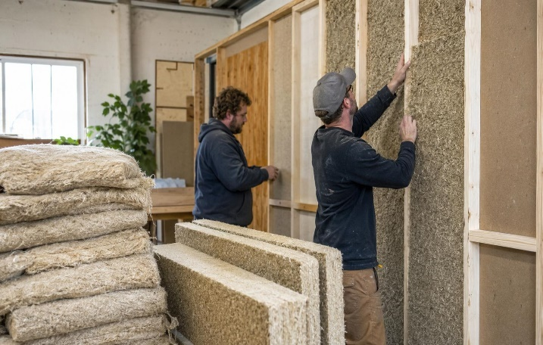
Figure 1 – Bio based materials Figure 2 – Bio based materials
The study also identifies opportunities associated with wood and forestry residues, particularly in rural and mountainous areas. Wood fibers, sawdust, wood chips and other residues from forestry and wood processing can be combined with agricultural fibers to develop insulation and composite materials.
The potential is particularly relevant for territories such as Korçë, where agricultural production, forestry resources, rural settlements and traditional construction practices create favorable conditions for a local bio-based construction value chain.
However, the quick scan highlights several structural gaps and barriers. Albania currently lacks a mature market and dedicated value chain for agro-based construction materials. There is limited systematic collection and mapping of agricultural residues according to their quantity, seasonality, geographic concentration and suitability for construction applications. Technical standards, certification procedures and testing capacities for bio-based construction products remain limited, while knowledge among farmers, construction companies, architects and public authorities is still developing. Other barriers include fragmented agricultural production, logistical costs for collecting and processing residues, uncertain market demand, limited investment in processing technologies, and insufficient integration between agricultural waste policies, construction policies and climate strategies.
A further challenge is the limited recognition of agricultural biomass as a potential carbon-storage material within local climate and development planning. Existing planning instruments tend to address agriculture, waste management, energy efficiency, buildings and climate mitigation as separate sectors. This creates an opportunity to introduce a more integrated approach in the revision of the Korçë Municipality Development Plan and Climate Mitigation Strategy, linking agricultural-resource management with circular construction, local economic development and carbon reduction.
The development of an Agro-Building Carbon approach in Albania could therefore create multiple environmental, economic and territorial benefits. It could reduce the open burning or disposal of agricultural residues, substitute carbon-intensive construction materials, improve resource efficiency, create additional income opportunities for farmers and agro-processors, stimulate local green enterprises and support rural employment. For Korçë Municipality, the approach could be developed around local biomass mapping, pilot collection systems, partnerships with farmers and agro-processors, research institutions and construction companies, and demonstration buildings using locally sourced bio-based materials. The approach could subsequently be replicated in other Albanian municipalities with significant agricultural and forestry resources.
Overall, the Quick Scan concludes that Agro-Building Carbon represents an emerging opportunity for Albania to connect agriculture, construction, circular economy and climate policy. While the sector is still at an early stage and requires further technical and economic assessment, the availability of agricultural and forestry residues, combined with increasing demand for low-carbon construction solutions, provides a strong basis for further development. The revision of the Korçë Municipality Development Plan and Climate Mitigation Strategy offers a timely opportunity to embed these principles into local policy and establish the institutional framework for pilot actions, investment and future replication.

1.3 Introduction on agro-building concept and Objectives

1.3.1 Background
Agro-Building is an emerging approach that connects the agricultural and construction sectors by transforming agricultural, forestry and agro-industrial biomass residues into construction materials and building products. Instead of treating crop residues, pruning materials, straw, fibers, husks, stalks, sawdust and other biomass as waste, the approach considers them as valuable renewable resources that can be incorporated into insulation, boards, panels, bio-composites, lightweight blocks and other construction applications. The concept therefore creates a link between agricultural production, biomass management, material innovation, construction and climate action.
The relevance of Agro-Building goes beyond the substitution of conventional construction materials. When biomass originating from atmospheric CO₂ is incorporated into long-lived building products, part of that carbon can remain stored in the building for the duration of the product's service life. This creates an opportunity to move from a linear model produce, consume and dispose towards a circular model in which locally available biological resources are retained in the economy for longer periods. The actual climate benefit depends on sustainable biomass sourcing, processing energy, transport, product durability, end-of-life treatment and the extent to which the bio-based product replaces a more carbon-intensive alternative.
Agro-Building can contribute to climate mitigation through several complementary pathways. First, agricultural residues that would otherwise be open-burned, decomposed rapidly or disposed of can be redirected towards durable products. This can reduce emissions associated with inappropriate residue management. Second, bio-based construction materials can substitute part of the demand for conventional materials whose production can be energy- and carbon-intensive, particularly where they replace fossil-based insulation or materials with high embodied emissions.
Third, the approach can support local and shorter supply chains. Producing construction materials from biomass available within or near the territory can reduce transport requirements and retain more economic value locally. The climate performance should nevertheless be demonstrated through appropriate life-cycle assessment (LCA) rather than assumed solely from the fact that a material is bio-based.
A key feature of Agro-Building is its potential contribution to biogenic carbon storage. Plants absorb CO₂ from the atmosphere during their growth through photosynthesis. If agricultural biomass is transformed into a durable building product rather than rapidly decomposed or burned, the carbon contained in that biomass can remain stored for years or decades. In this sense, buildings can function as temporary or long-term carbon reservoirs. Straw, wood fibers, agricultural fibers and other suitable biomass can therefore become part of a material pathway that keeps atmospheric carbon outside the atmosphere for the lifetime of the construction product.
It is important, however, to distinguish carbon storage from permanent carbon removal. Agro-Building does not automatically constitute permanent carbon removal. The climate benefit depends on the entire carbon cycle and on the lifetime and end-of-life management of the material. A credible Albanian Agro-Building framework should therefore establish methodologies for measuring, reporting and verifying carbon stored in construction products and avoid double counting with carbon already accounted for in agriculture or forestry. Agro-Building is strongly aligned with the principles of the circular bioeconomy, where renewable biological resources are maintained in productive use and waste is minimized. Agricultural residues become secondary raw materials, creating new economic value from resources that previously had limited or no market value.
This can establish new local value chains involving farmers, cooperatives, agro-processors, biomass collectors, manufacturers, architects, engineers, construction companies, universities and municipalities. Such cooperation can generate new products and services while reducing pressure on virgin resources and improving resource efficiency.
For municipalities such as Korçë, this approach could be particularly relevant because it connects agricultural production and rural areas with urban construction demand. A local biomass resource map could identify which residues are available, where they are generated, their seasonal availability and which construction applications may be technically and economically appropriate. Agro-Building can provide an additional dimension to sustainable agricultural production by giving economic value to residues and by-products. Farmers can potentially obtain additional revenue from materials that were previously considered waste, while better residue management can reduce open burning and uncontrolled disposal.
The approach should nevertheless respect the principle that not all agricultural residues should be removed from fields. Crop residues can play an important role in maintaining soil organic matter, protecting soils from erosion and supporting nutrient cycling. Therefore, only the sustainable surplus should be considered for construction applications. Biomass extraction should be based on agricultural and environmental assessments to ensure that carbon and nutrient cycles within agricultural soils are not negatively affected.
Agro-Building can become a tool for rural economic diversification. It creates possibilities for new enterprises involved in biomass collection, preprocessing, transport, processing and manufacturing of bio-based construction products. These activities can create employment and additional income in rural areas and strengthen links between primary agricultural production and higher-value manufacturing.
For the Korçë territory, this could support a territorial development model in which agricultural resources are not exported as low-value commodities or treated as waste but are progressively transformed into higher-value products. Local production of construction materials could also support green entrepreneurship, innovation and skills development, particularly through cooperation with vocational education institutions, universities and SMEs.
Finally, Agro-Building contributes to the transition towards low-carbon construction by promoting materials with potentially lower embodied carbon and, in some applications, good thermal performance. Bio-based insulation materials, for example, can contribute simultaneously to reducing the embodied emissions of buildings and improving energy efficiency during their operation. The approach should therefore be integrated with broader measures such as energy-efficient building design, renovation, renewable energy, sustainable sourcing, material reuse and circular construction. It should not be viewed as a replacement for energy efficiency but as an additional component of a holistic low-carbon building strategy.

Objectives of the Quick Scan
The Quick Scan aims to provide a concise, evidence-based overview of Albania’s potential for bio-based construction materials and carbon-positive agricultural value chains. To achieve this, the study focuses on the following objectives:
1. Identify existing Albanian initiatives related to agricultural biomass and carbon storage
To map current projects, programs, and practices that already utilize agricultural residues or promote carbon sequestration in farming systems. This includes initiatives in cereals, forage, legumes, and sugar beet production that generate significant biomass streams.
2. Identify existing or emerging uses of agricultural materials in construction
To document how agricultural residues (such as straw, maize stalks, and beet pulp) are currently being used or have potential to be used in bio-based building materials, insulation, composites, and other climate-positive construction applications.
3. Map relevant stakeholders and value chains
To identify farmers, cooperatives, processors, construction actors, research institutions, public authorities, and SMEs involved in agricultural production, biomass processing, and bio-material innovation. This mapping clarifies who participates in each step of the value chain and where new connections can be formed.
4. Review the relevant policy and regulatory framework
To analyze Albanian and EU policies that influence agricultural biomass use, carbon storage, and bio-based construction including the Green Deal, CRCF, CAP, rural development programs, and national agricultural strategies.
5. Identify good practices and innovative initiatives
To highlight examples from Albania and Europe where agricultural residues are successfully transformed into construction materials, carbon-storing products, or circular economy solutions.
These practices serve as models for replication or adaptation in the Korça Region and beyond.
6. Assess barriers to wider adoption
To identify technical, economic, regulatory, and social obstacles that limit the use of agricultural biomass in construction or carbon-positive land management. This includes gaps in certification, lack of processing infrastructure, limited awareness, or insufficient policy incentives.

7. Identify opportunities for pilot actions and policy improvement
To propose targeted interventions such as pilot projects, regional strategies, funding mechanisms, or regulatory adjustments that can accelerate the adoption of bio-based construction materials and carbon-positive agricultural practices.

Methodology
The Quick Scan Study will apply a multi-method, evidence-based and participatory methodology designed to provide a rapid but sufficiently comprehensive assessment of the potential for developing Agro-Building Carbon approaches in Albania, with particular relevance to the Korçë Municipality Development Plan and Climate Mitigation Strategy. The methodology combines documentary analysis, stakeholder knowledge and practical examples in order to connect agricultural biomass resources with climate mitigation, carbon storage, circular bioeconomy and low-carbon construction.
The methodological approach is aligned with the emerging European policy direction towards sustainable bioeconomy and bio-based construction. The EU's 2025 Bioeconomy Strategy specifically identifies bio-based construction products, sustainable biomass supply, circular use of biological resources and biogenic carbon storage as areas with significant development potential.
1. Desk research and baseline assessment.
The study will begin with a review of available statistical, institutional, technical and sectoral information concerning agriculture, forestry, agro-processing, biomass residues, construction, waste management, climate change and circular economy in Albania. The desk review will establish a baseline of available agricultural and forestry resources and identify the main types of residues that could potentially be used as feedstock for construction materials. Particular attention will be given to the Korçë Municipality and its surrounding rural areas, considering the availability, seasonality, geographic concentration and current use of agricultural residues.
2. Review of national, regional and EU policies.
A structured policy review will assess how existing policies and strategies address biomass valorization, agricultural residues, circular economy, sustainable construction, climate mitigation, carbon storage, rural development and resource efficiency. The analysis will cover relevant Albanian legislation and strategies, as well as EU frameworks and policy developments relevant to Albania. Specific attention will be given to identifying how the findings of the Quick Scan can be incorporated into the revision of the Korçë Municipality Development Plan and Climate Mitigation Strategy, including opportunities for new objectives, measures, indicators and pilot actions.

3. Mapping of existing projects and initiatives.
A mapping exercise will identify existing Albanian and international projects, businesses, research activities, demonstration projects and initiatives using agricultural or forestry biomass for construction or other high-value applications. The mapping will examine their location, biomass source, technology, products, partners, level of maturity, financing model and environmental benefits. Initiatives demonstrating carbon storage, circularity or successful cooperation between farmers and construction actors will receive particular attention.

4. Stakeholder focus-groups.
Semi-structured focus-groups will be conducted with a selected group of stakeholders representing the main parts of the potential value chain. These may include municipal authorities, agricultural producers and associations, agro-processors, forestry operators, construction companies, architects and engineers, universities and research institutions, waste-management actors, SMEs and relevant national institutions. Focus Groups will explore current practices, resource availability, technical knowledge, market demand, regulatory constraints, investment needs and perceived opportunities.
5. Gap and opportunity analysis.
The final analytical stage will consolidate the evidence through a Gap and Opportunity Matrix. Gaps will be assessed across policy and regulation, biomass availability and logistics, technology and processing, standards and certification, research and innovation, financing, market demand, skills and stakeholder cooperation. Opportunities will be assessed in relation to carbon mitigation and storage, circular bioeconomy, sustainable agriculture, rural employment, local economic development and low-carbon construction.
The methodology will conclude with a prioritization of feasible interventions, distinguishing between short-, medium- and longer-term actions. The results will provide the evidence base for recommendations to policy makers and stakeholders and, importantly, will identify concrete opportunities for incorporating Agro-Building Carbon measures, pilot projects, indicators and investment priorities into the revised Korçë Municipality Development Plan and Climate Mitigation Strategy.

4. National Context: Agriculture, Biomass and Construction

4.1 Korça region overview
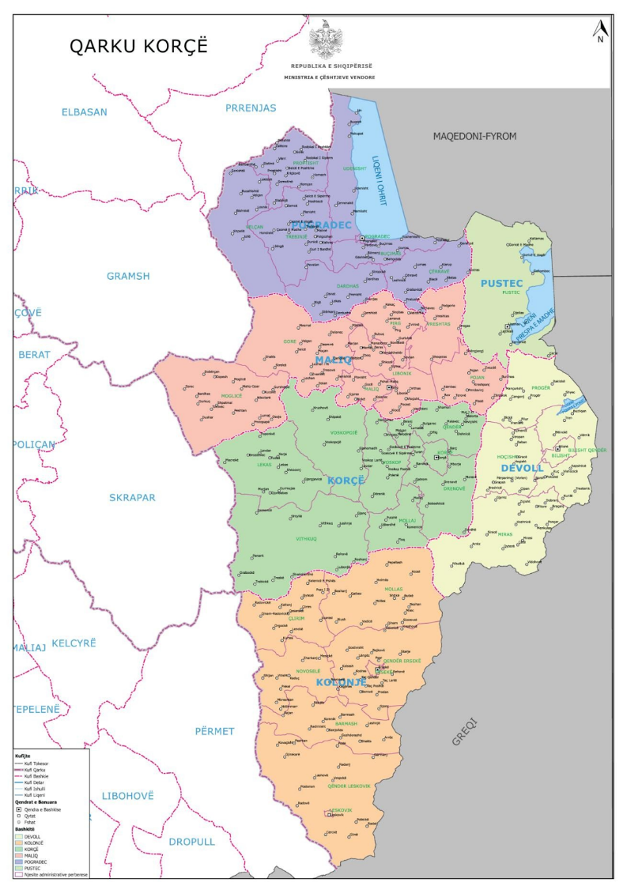
The Korça Region, located in southeastern Albania, represents one of the country’s most diverse, fertile, and ecologically significant agricultural territories. Its landscape stretches from wide cereal plains to high‑altitude pastures, from forested slopes to mixed crop basins, forming a complex mosaic of ecosystems that interact continuously with human cultivation. In 2024, the municipalities of Korçë, Ersekë, Maliq, Pogradec, Devoll, and Pustec together shape a regional identity defined by productive agriculture, rich biodiversity, and substantial biomass flows.
Figure 3 - Korça Region
Across this territory, agriculture is not uniform, it is layered. The plains of Korçë and Maliq are dominated by extensive cereal production, where wheat, corn, and barley form the backbone of
local food systems and biomass availability. The plateaus of Ersekë and Devoll are characterized by vast forage surfaces, supporting both livestock and high‑carbon perennial grasses. The basins of Pogradec and Pustec introduce diversity through legumes, potatoes, vegetables, and small industrial crops, enriching soil fertility and contributing to a more resilient agricultural structure.
This agricultural diversity is complemented by natural ecosystems that surround and interweave with cultivated land. Forests, both coniferous and broadleaf, act as long‑term carbon reservoirs, storing carbon in woody biomass and deep soil layers. Pastures and meadows, especially in Kolonjë (Ersekë), function as dynamic carbon sinks, where perennial grasses and deep root systems continuously regenerate organic matter. Together, these ecosystems stabilize the region’s climate, protect soil, and enhance ecological resilience.
The quick scan integrates municipal‑level agricultural data with environmental interpretation, offering a comprehensive view of how Korça’s cultivated and natural systems contribute to carbon fixation, biomass production, and future opportunities. It highlights the region’s strengths: its large cereal surfaces, its extensive forage systems, its pockets of legume and vegetable diversity, and its ecological backbone of forests and pastures. It also underscores Korça’s emerging relevance to bio‑building materials, circular agriculture, and regenerative land management, especially as Europe advances frameworks such as the Carbon Removal Certification Framework (CRCF).
In this context, Korça stands not only as an agricultural region, but as a territory with the potential to evolve into a strategic hub for carbon‑rich biomass, sustainable construction materials, and climate‑positive land practices, grounded in the resources, ecosystems, and cultivation patterns already present today.

4.2 Combined Municipal Overview
The Korça Region is composed of six municipalities: Korçë, Ersekë, Maliq, Pogradec, Devoll, and Pustec, each contributing uniquely to the agricultural and ecological landscape of southeastern Albania. Together, these municipalities form a region where cereals, forage crops, legumes, vegetables, and industrial crops interact with forests, pastures, and shrublands to create a dynamic environment for carbon fixation, biomass production, and the emergence of bio‑based material value chains.
What makes Korça distinct is the layered nature of its landscapes. The region is not defined by a single agricultural pattern; instead, it is shaped by a patchwork of micro‑environments that shift from one municipality to another. Wide plains, elevated plateaus, lake‑side basins, and mountain foothills all coexist within a relatively compact territory. This diversity creates a natural resilience: different crops thrive in different microclimates, and ecological systems complement agricultural production.
Agriculture here is both traditional and forward‑looking. Wheat, corn, barley, rye, alfalfa, beans, potatoes, vegetables, and sugar beet form the backbone of local food systems and biomass flows. These crops absorb CO₂ through photosynthesis, storing carbon in stems, leaves, roots, and soil. Meanwhile, forests and pastures act as long‑term carbon reservoirs, capturing atmospheric carbon and embedding it in woody biomass and deep soil layers. This combination of cultivated and natural systems gives Korça a multi‑layered carbon landscape, where annual crops, perennial grasses, and long‑lived forests work together.
The region’s agricultural diversity also creates opportunities for bio‑based materials, circular agriculture, and regenerative land management. Even though Korça does not yet cultivate hemp, bamboo, Paulownia, or other specialized bio‑building crops, it produces large quantities of agricultural residues like straw, forage biomass, beet pulp, legume stalks, vegetable waste, that can be transformed into insulation, fiber panels, composites, and biodegradable products.
In this context, Korça stands not only as an agricultural region, but as a territory with the potential to evolve into a strategic hub for carbon‑rich biomass, sustainable construction materials, and climate‑positive land practices grounded in the resources, ecosystems, and cultivation patterns already present today.

Table 1- The area planted with different products in the region of Korça

4.2.1 Korçë Municipality
Korçë stands as a cereal‑dominated agricultural zone, shaped by broad, open fields and long‑established cultivation traditions. With 5,195 hectares of cultivated land, Korçë is one of the region’s most productive cereal basins. Wheat occupies 2,480 ha, forming the backbone of local grain production and contributing significantly to food security. Corn (1,045 ha) and barley (885 ha) add substantial biomass, while alfalfa (570 ha) and rye (215 ha) diversify the agricultural landscape with perennial and cold‑resistant crops.

Figure 4 - Illustrative image of crops in the region
Sugar beet (176 ha) introduces an industrial crop component. Historically, sugar beet has been linked to processing industries, and even though those industries have changed over time, the crop remains valuable due to its high root biomass, which stores carbon deep in the soil.
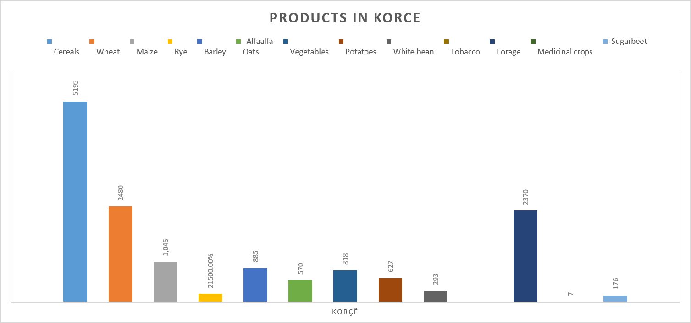
Figure 5 – Areas of products planted by categories in Korçë
Environmentally, Korçë’s crops contribute significantly to carbon fixation. Corn and sugar beet, due to their high biomass production and efficient photosynthesis, absorb more CO₂ than wheat or barley. Corn’s C4 photosynthetic pathway allows rapid growth and high carbon uptake, while sugar beet stores carbon in deep root systems. This positions Korçë as a municipality with strong potential for carbon‑rich biomass, even though it does not yet cultivate hemp, bamboo, Paulownia, or other bio‑building crops.

4.2.2 Ersekë Municipality
Ersekë presents a forage‑intensive agricultural structure, shaped by its plateau geography, cooler climate, and livestock‑friendly terrain. With 2,040 ha of cereals and 2,230 ha of forage crops, Ersekë is one of the region’s most balanced and ecologically valuable agricultural zones. Wheat (820 ha), corn (350 ha), barley (320 ha), rye (100 ha), and alfalfa (450 ha) form the cereal group, while forage crops dominate the landscape.
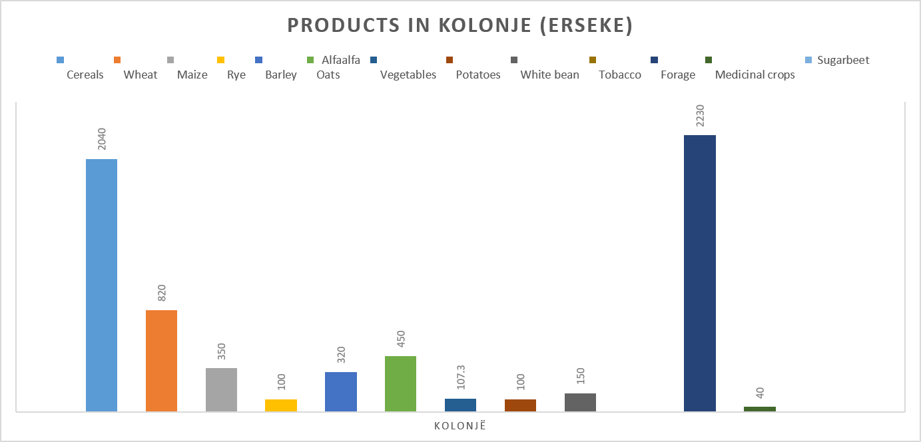
Figure 6 – Areas of products planted by categories in Kolonjë
Ersekë’s agricultural identity is closely tied to pastoral systems. The municipality’s wide pastures and perennial grasses support livestock, but they also play a major role in soil carbon storage. Forage crops, harvested multiple times per year, accumulate substantial carbon in both biomass and soil. Corn, as a C4 plant, absorbs large amounts of CO₂, while alfalfa contributes deep‑rooted biomass that enhances soil carbon retention.
Ersekë’s landscape aligns naturally with regenerative agriculture, carbon‑intensive biomass production, and climate‑positive land management. Its combination of forage systems, perennial grasses, and cereal production makes it one of the strongest contributors to ecological carbon fixation.

4.2.3 Maliq Municipality
Maliq is the largest agricultural municipality in the region, historically shaped by irrigation systems, fertile plains, and large‑scale cultivation. Cereals cover 7,209 ha, including wheat (3,521 ha), corn (2,425 ha), barley (946 ha), rye (103 ha), and alfalfa (214 ha). Forage crops occupy 3,604 ha, and sugar beet covers 261 ha, making Maliq a powerhouse of both food production and biomass availability.
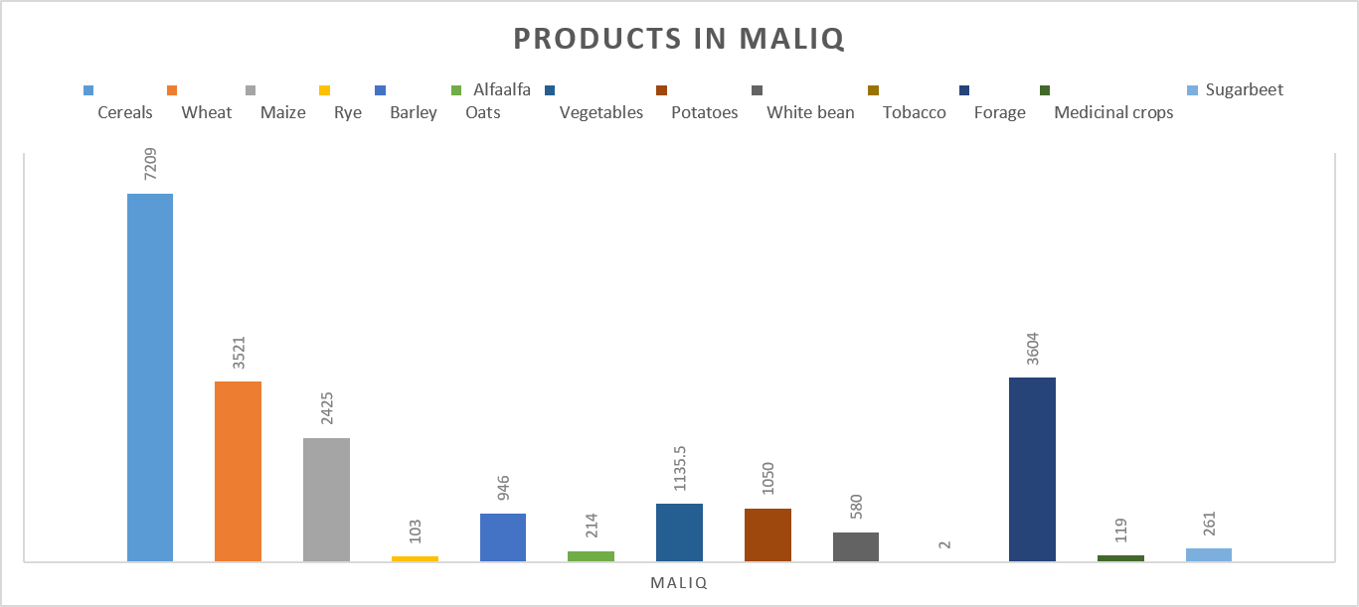
Figure 7 – Areas of products planted by categories in Maliq
Maliq’s agricultural scale makes it a major contributor to regional biomass. Corn and forage crops stand out for their high carbon‑fixation capacity. Corn’s C4 photosynthesis allows rapid biomass accumulation, while forage crops, due to repeated harvesting, store carbon in soil and plant matter. Wheat and barley contribute large quantities of straw, which can be used for bio‑insulation, fiber panels, and biomass composites.
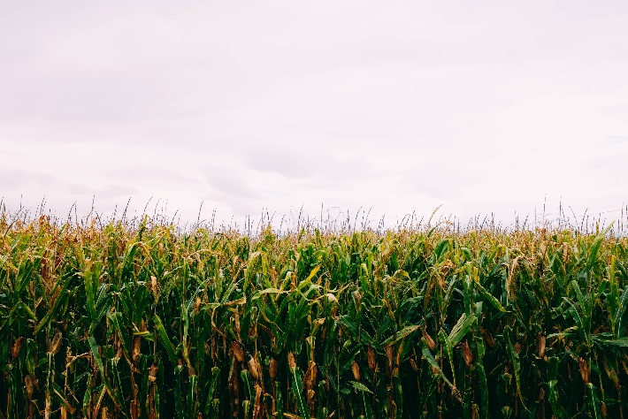
Figure 8 – Illustrative image of Corn field
Maliq’s combination of large cereal surfaces, extensive forage systems, and industrial crops positions it as a key candidate for bio‑based material production and circular agriculture. Its agricultural residues form one of the region’s strongest biomass streams.

4.2.4 Pogradec Municipality
Pogradec presents a diversified agricultural structure, shaped by its basin geography, fertile soils, and proximity to Lake Ohrid. With 3,660 ha of cereals, 2,096 ha of forage crops, 521 ha of beans, and 330 ha of potatoes, Pogradec is the most legume‑intensive municipality in the region.
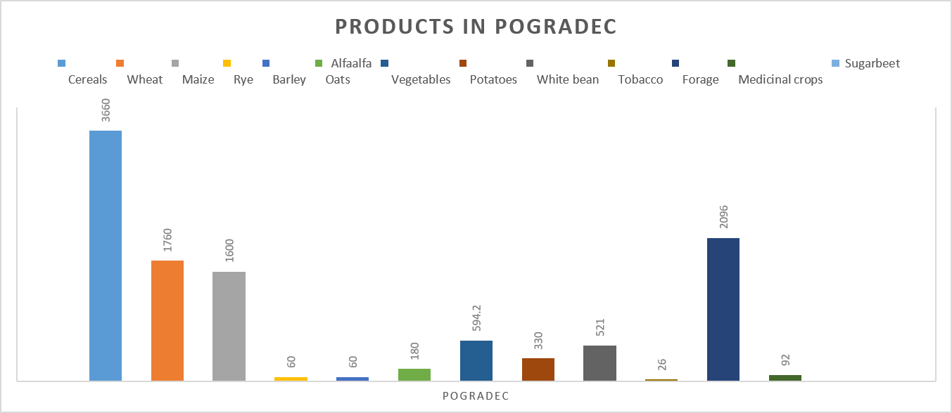
Figure 9 – Areas of products planted by categories in Pogradec
Legumes play a special role in environmental sustainability. Beans improve soil nitrogen, reducing the need for synthetic fertilizers and indirectly supporting carbon storage. Potatoes contribute root biomass, adding organic matter to the soil. Cereals and forage crops provide the bulk of biomass, while legumes enhance soil fertility and ecological resilience.
Pogradec’s diversity makes it suitable for mixed circular agriculture, combining cereals, legumes, and forage biomass. Its crop mix supports soil health, biodiversity, and regenerative practices.

4.2.5 Devoll Municipality
Devoll cultivates 4,135 ha of cereals, including wheat (2,575 ha), corn (920 ha), barley (430 ha), rye (150 ha), and alfalfa (60 ha). Forage crops cover 3,320 ha, creating a balanced agricultural system that supports both livestock and biomass production.
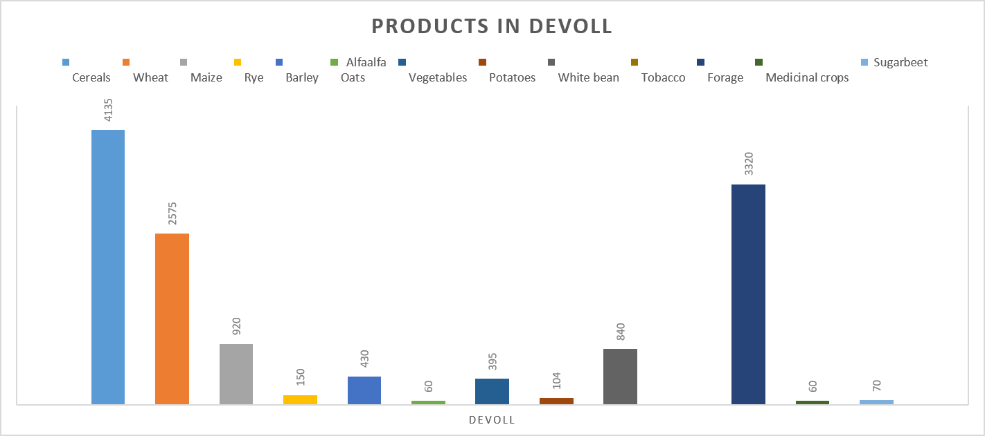
Figure 10 – Areas of products planted by categories in Devoll
Devoll’s agricultural system contributes significantly to carbon fixation. The combination of cereals and forage crops supports both above‑ground biomass and soil carbon accumulation. Wheat and barley generate straw, while forage crops provide continuous biomass streams.
Devoll’s structure is well‑suited for biomass supply chains, especially straw and forage‑based materials. Its balanced landscape makes it a stable contributor to regional food systems and ecological carbon storage.

4.2.6 Pustec Municipality
Pustec is the smallest agricultural municipality, shaped by its lakeside geography, smaller cultivation surfaces, and mixed crop patterns. It has 335 ha of cereals (wheat 100 ha, corn 80 ha, barley 5 ha, alfalfa 150 ha). Forage crops cover 203 ha, while beans (50 ha), potatoes (30 ha), vegetables (36 ha), and sugar beet (10 ha) add diversity.
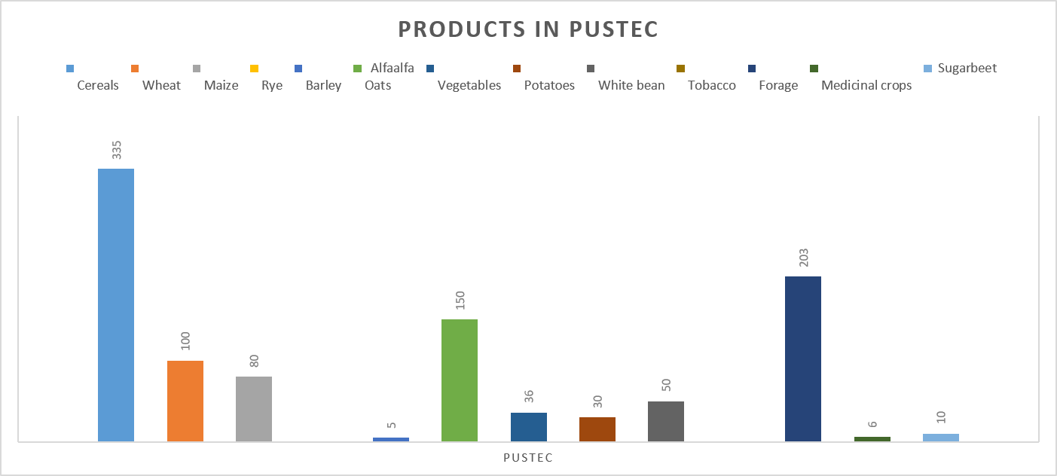
Figure 11 –Areas of products planted by categories in Pustec
Despite its small size, Pustec contributes to carbon fixation through alfalfa’s deep roots, bean nitrogen fixation, and sugar beets root biomass. Pustec’s scale makes it suitable for community‑level circular agriculture, small bio‑material pilots, and regenerative micro‑projects. Its diverse crop mix supports soil health and ecological resilience.

5.Comparative Agricultural Analysis Between the Korça Region and Albania
The Korça Region stands out as one of Albania’s most structurally diverse and agriculturally productive territories. Its six municipalities: Korçë, Maliq, Pogradec, Devoll, Kolonjë (Ersekë), and Pustec, collectively form a landscape where cereal plains, forage plateaus, legume basins, and mixed cropping systems interact with forests and pastures to create a multi‑layered carbon and biomass environment. To understand Korça’s national significance, this chapter compares the region’s agricultural totals with Albania’s national production figures. The comparison highlights Korça’s contribution to food systems, biomass availability, carbon fixation, and its strategic potential for future bio‑based industries.

5.1 Numerical Comparison: Korça Region vs. Albania
The following table presents the total cultivated area for each crop category in the Korça Region and compares it with Albania’s national totals. The final column shows Korça’s percentage share of Albania’s total agricultural surface for each crop.
Crop Category | Korça Region Total (ha) | Albania Total (ha) | Korça Share (%)
Cereals | 22,574 | 126,131.5 | 17.9%
Wheat | 11,256 | 45,970 | 24.5%
Maize | 6,420 | 57,611.5 | 11.1%
Rye | 628 | 1,170 | 53.6%
Barley | 2,646 | 7,500 | 35.3%
Alfalfa / Oats | 1,624 | 13,877 | 11.7%
Vegetables | 3,086 | 34,695.878 | 8.9%
Potatoes | 2,241 | 10,368 | 21.6%
White Bean | 2,434 | 12,327.5 | 19.7%
Tobacco | 28 | 906.8 | 3.1%
Forage | 13,823 | 211,877.63 | 6.5%
Medicinal Crops | 324 | 7,507.6 | 4.3%
Sugarbeet | 517 | 517 | 100%
Table 2 – Comparison Albania vs Korce region
Korça’s National Strengths
The comparison reveals several areas where the Korça Region plays a decisive national role.
- Complete National Dominance
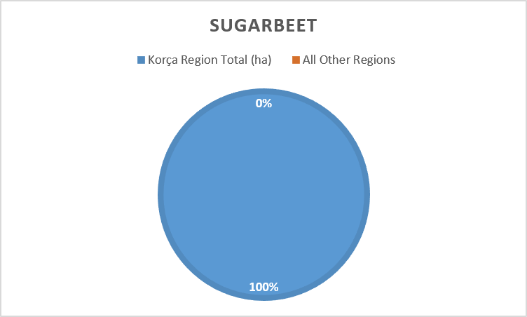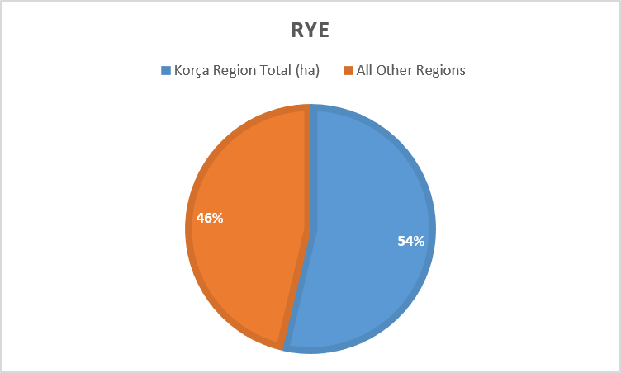
*Figure 12 - Sugar beet (100 %) *Figure 13 - Rye (53.6%)
Korça is the only region in Albania cultivating sugar beet. This gives it a unique industrial biomass advantage, especially for bio‑materials and bio‑based composites.

- Strong National Leadership
Korça contributes significantly to several key crops. More than half of Albania’s rye cultivation is concentrated in Korça, especially in Ersekë and Devoll.
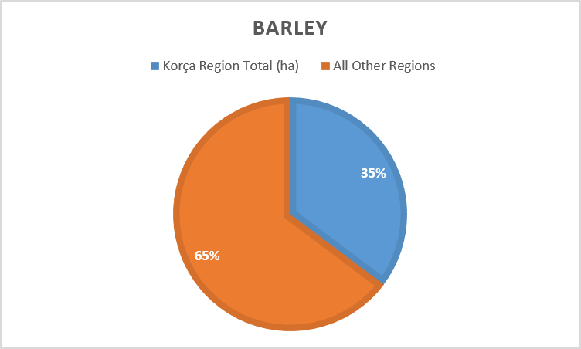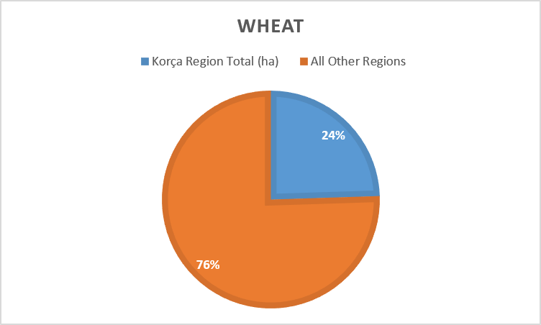
*Figure 14 - Barley (35.3%) *Figure 15 - Wheat (24.5%)
Korça is a major barley producer, contributing over one‑third of national production. Nearly one‑quarter of Albania’s wheat comes from Korça, confirming its role as a cereal powerhouse.
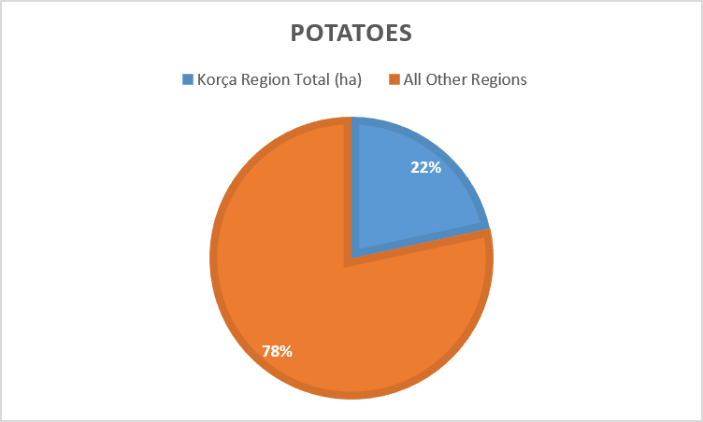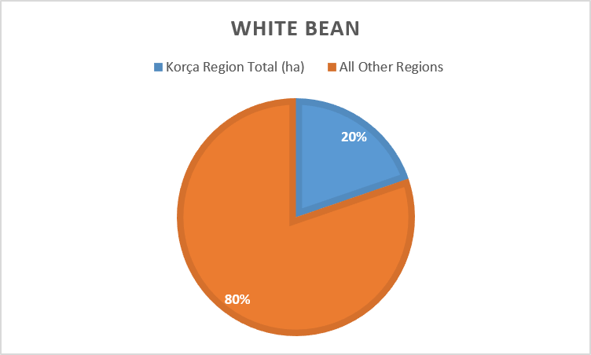
*Figure 16 - Potatoes (21.6%) *Figure 17 - White beans (19.7%)
Korça maintains its historical reputation as one of Albania’s leading potato regions. Pogradec and Devoll significantly strengthen Korça’s national share in legumes. These crops are also among the most important for biomass generation, soil carbon storage, and bio‑material production, making Korça a strategic region for future circular economy initiatives.
Korça shows stable but not dominant contributions in:
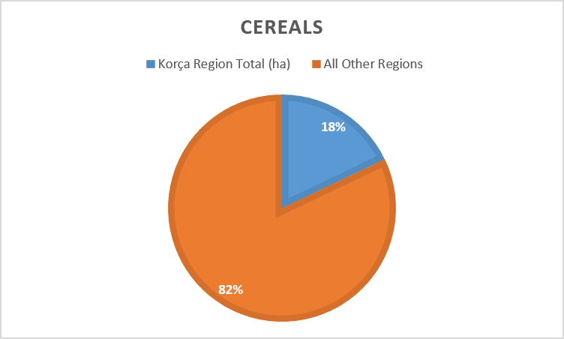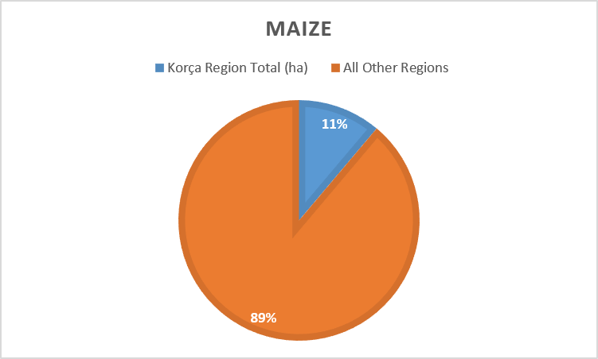
*Figure 18 - Cereals overall (17.9%) *Figure 19 - Maize (11.1%)
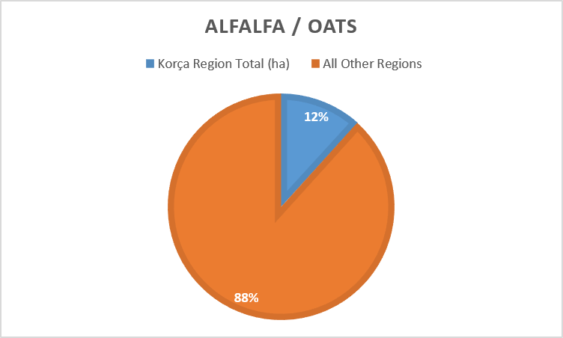

*Figure 20 - Alfalfa/Oats (11.7%)
These values indicate that Korça is a reliable contributor to Albania’s agricultural base, especially in carbon‑rich cereal systems.

Korça’s lower contributions appear in:
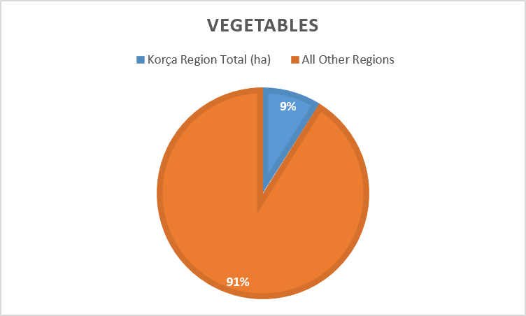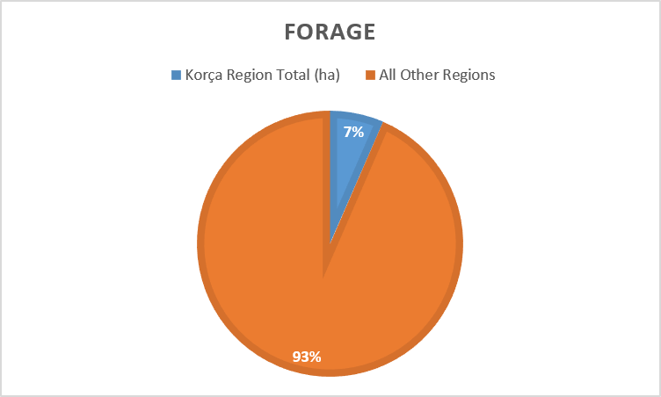
*Figure 21 - Vegetables (8.9%) *Figure 22 - Forage (6.5%)

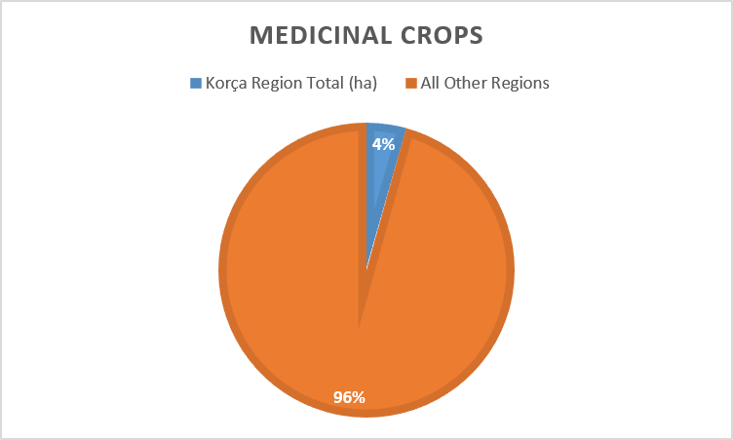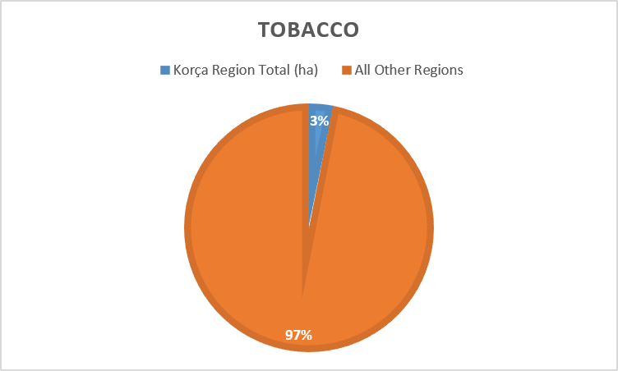
*Figure 23 - Medicinal crops (4.3%) *Figure 24 - Tobacco (3.1%)

Although forage has a low national share, it is extremely important within Korça Region for carbon storage, livestock systems, and regenerative agriculture.

6. Biomass and Carbon Implications
The comparison clearly demonstrates that the Korça Region holds a strategic position in Albania’s agricultural landscape, particularly in crops that generate high biomass and have strong carbon‑fixation potential. Crops such as wheat, barley, rye, maize, alfalfa, and sugar beet form the backbone of Korça’s agricultural identity. These crops are well‑known for producing substantial quantities of residual biomass, including cereal straw, maize stalks, alfalfa forage, and sugar beet pulp, all of which represent valuable carbon‑rich resources. Cereal crops like wheat, barley, and rye produce large volumes of straw, a dry lignocellulosic residue that is widely recognized for its suitability in bio‑insulation, straw‑based construction panels, and agricultural fiber composites. According to FAO and JRC studies, cereal straw contains high levels of structural cellulose and hemicellulose, making it an effective feedstock for bio‑based building materials that store carbon for decades. Similarly, maize generates robust stalk biomass that can be used in composite materials and biodegradable packaging. Alfalfa, with its perennial root system and dense above‑ground biomass, contributes both to soil carbon storage and to forage streams that can be valorized in bio‑material processes.
Sugar beet, where Korça holds a 100% national share, is particularly significant. Beyond its role as an industrial crop, sugar beet generates beet pulp, a moist fibrous residue that can be processed into bio‑binders, bio‑resins, and other carbon‑storing materials. This unique dominance positions Korça as the only Albanian region capable of supplying sugar‑beet‑derived biomass for emerging bio‑material industries. Together, these crops create a diversified biomass portfolio that aligns strongly with the European Union’s Carbon Removal Certification Framework (CRCF). CRCF emphasizes measurable carbon sequestration, long‑term storage, and traceable biomass flows, all of which are directly supported by Korça’s agricultural profile. The region’s combination of high‑volume cereal residues, perennial forage systems, and exclusive sugar beet production makes it a prime candidate for CRCF‑aligned bio‑material value chains, where agricultural residues are transformed into long‑lasting construction materials that lock carbon into buildings for decades.
In this context, Korça’s agricultural landscape is not only productive but also strategically positioned to contribute to climate‑positive construction, regional carbon removal strategies, and new circular economy pathways that connect farmers, processors, and the construction sector.

7. Strategic Significance for Albania
The Korça Region’s agricultural profile demonstrates a rare combination of productivity, ecological diversity, and strategic potential for Albania’s future climate‑positive development. With high outputs in cereals and industrial crops, substantial biomass availability, and continuous carbon fixation across multiple ecosystems, the region stands out as one of the country’s most promising territories for innovation in land management and bio‑based industries.
Korça’s agricultural landscape is characterized by a balanced mix of annual crops (such as wheat, barley, maize, rye, and sugar beet), perennial forage systems (including alfalfa and mixed pastures), legumes (notably white beans), and root crops (potatoes and sugar beet). This diversity creates a stable and resilient agricultural base capable of supporting multiple value chains. The region’s unique national role in sugar beet production, holding 100% of Albania’s total, further strengthens its position as a strategic supplier of biomass for industrial and bio‑material applications.
This combination of crop diversity, biomass availability, and ecological richness makes Korça exceptionally well‑positioned for:

7.1 Regenerative Agriculture
Regenerative agriculture refers to a set of farming practices designed to restore and enhance the natural functioning of ecosystems, rather than simply minimizing harm. It focuses on rebuilding soil fertility, increasing biodiversity, and improving water retention while simultaneously producing food and biomass. Regenerative agriculture aims to create self‑sustaining agricultural ecosystems that improve over time. In Korça, the combination of cereals, legumes, forage, and root crops provides the structural diversity needed for regenerative cycles. This makes the region well‑suited for practices that enhance soil carbon, reduce erosion, and strengthen ecological resilience.
Includes:
- Soil‑building practices such as crop rotation, cover cropping, reduced tillage, and organic amendments.
- Perennial systems like alfalfa and forage crops that maintain living roots year‑round and continuously store carbon in soils.
- Biodiversity enhancement, through mixed cropping systems and integration of legumes (e.g., white beans) that naturally fix nitrogen.
- Minimizing soil disturbance, which protects soil structure and microbial life.
- Increasing organic matter, which improves soil fertility and long‑term carbon storage.

7.2 Carbon Farming
Carbon farming is a land‑management approach where farmers adopt practices that increase carbon sequestration in soils and biomass. Under frameworks like the EU’s CRCF, farmers may eventually receive financial incentives for measurable carbon removal. Carbon farming transforms agriculture into a climate‑positive activity, where farmers are recognized not only for producing food but also for removing CO₂ from the atmosphere. Korça’s high‑biomass crops and perennial systems make it one of Albania’s strongest candidates for carbon farming initiatives.
Includes:
- Increasing biomass production through high‑yield crops such as wheat, barley, maize, and sugar beet.
- Enhancing soil carbon storage via perennial forage systems (e.g., alfalfa) and reduced tillage.
- Managing residues (straw, stalks, beet pulp) in ways that retain carbon rather than releasing it through burning.
- Monitoring and verification of carbon gains, aligned with CRCF methodologies.

7.3 Circular Economy Development
Circular economy development focuses on closing material loops, ensuring that resources are reused, recycled, or transformed into new products rather than wasted. In agriculture, this means turning residues into valuable materials. A circular economy transforms Korça’s agricultural by‑products into economic opportunities. Instead of being burned or discarded, residues become inputs for bio‑based industries, strengthening rural economies and reducing environmental impact.
Includes:
- Valorization of agricultural residues such as straw, maize stalks, and sugar beet pulp.
- Replacing linear “produce–use–discard” systems with circular “produce–use–recycle” systems.
- Creating new value chains where farmers supply biomass to construction, packaging, or bio‑material industries.
- Reducing waste and emissions, especially from residue burning.

7.4 Bio‑Based Construction Materials
Bio‑based construction materials are building components made from renewable biological sources, which store carbon long‑term and replace high‑emission materials like concrete and steel. Bio‑based materials lock carbon into buildings for decades, contributing to climate mitigation. Korça’s dominance in sugar beet and cereals provides a consistent biomass supply, making it a prime region for developing bio‑material industries aligned with the EU’s CRCF.
Includes:
- Straw‑based insulation panels, using wheat, barley, and rye straw.
- Agricultural fiber composites, made from maize stalks or mixed cereal residues.
- Bio‑binders and resins, derived from sugar beet pulp and other lignocellulosic materials.
- Biodegradable packaging and structural elements, using agricultural fibers.

7.5 Climate‑Positive Land Management
Climate‑positive land management integrates agriculture, forestry, and pasture systems to maximize carbon fixation, enhance ecosystem resilience, and reduce emissions. Climate‑positive land management ensures that land use results in net carbon removal, not emissions. Korça’s mosaic of forests, pastures, and high‑biomass crops create a landscape capable of supporting long‑term carbon storage and ecological stability.
Includes:
- Multi‑ecosystem integration, combining forests, pastures, and croplands.
- High‑biomass cropping systems, which continuously remove CO₂ from the atmosphere.
- Sustainable pasture management, improving soil carbon and biodiversity.
- Protection of natural ecosystems, such as shrublands and forest areas that act as long‑term carbon reservoirs.
The comparative analysis between the Korça Region and Albania’s national agricultural totals confirms that Korça is not only a major agricultural contributor but also a strategic landscape for biomass, carbon fixation, and bio‑based value chains. Its dominance in sugar beet, rye, barley, wheat, potatoes, and legumes positions it as a key region for Albania’s transition toward regenerative agriculture and circular economy practices. Combined with its ecological diversity: forests, pastures, shrublands, and mixed cropping systems, Korça emerges as a central pillar in Albania’s sustainability strategies and a potential hub for carbon‑positive development

8.Forests & Pastures

Beyond its cultivated fields, the Korça Region is deeply shaped by its natural ecosystems, which form the ecological backbone of carbon storage, landscape stability, and long‑term environmental resilience. Although the forest and pasture data in the document refer to national Albania, they remain highly relevant to Korça because several of its municipalities, especially Ersekë, Devoll, and Pustec, contain or border extensive forested and pasture areas that directly influence the region’s ecological performance.
These ecosystems are not passive background elements. They actively regulate climate, stabilize soils, support biodiversity, and create the environmental conditions that allow Korça’s agricultural systems to thrive. Together, forests and pastures form a continuous green infrastructure that complements the region’s cultivated land.

8.1 Forests: The long‑term carbon reservoirs
Forests are among the most important components of the global carbon cycle. Through photosynthesis, trees absorb CO₂, convert it into biomass, and store carbon in trunks, branches, leaves, and roots. A portion of this carbon is also deposited into the soil, where it can remain for decades or centuries, making forests one of the most reliable long‑term carbon sinks.

Albania’s forests include:
Coniferous forests — 164,523.69 ha
These forests are dominated by species such as pine, fir, and juniper, which maintain photosynthesis year‑round. Their evergreen nature allows them to absorb carbon continuously, even during colder seasons when other vegetation is dormant. Coniferous forests are particularly important in mountainous and high‑altitude zones, where they stabilize slopes, prevent erosion, and regulate water cycles.
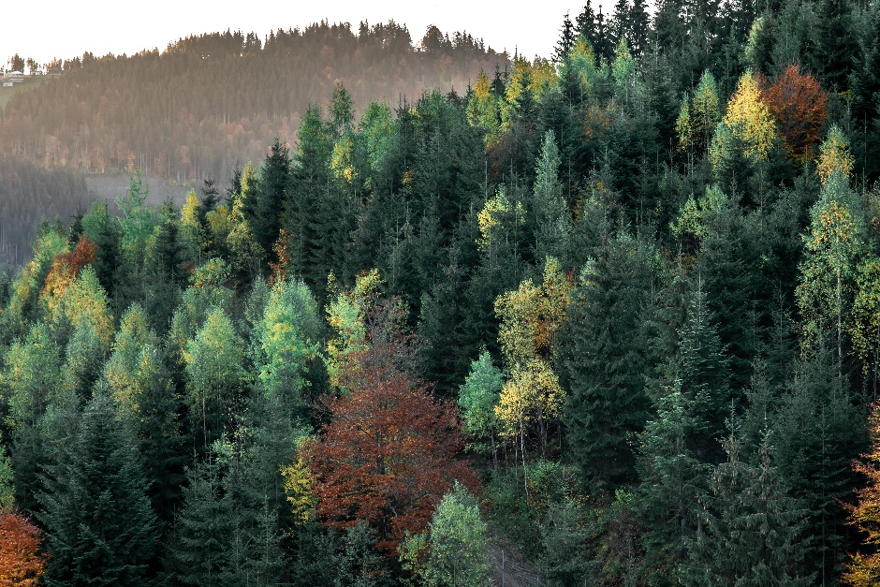
Figure 25 - Coniferous forests
Broadleaf forests — 571,166.37 ha
Broadleaf forests, including oak, beech, hornbeam, and chestnut, represent the largest forest category in Albania. Their extensive leaf area and large biomass make them highly effective at seasonal carbon sequestration. During spring and summer, broadleaf forests absorb large amounts of CO₂, storing it in wood and soil. In autumn, leaf litter enriches the soil with organic matter, contributing to long‑term carbon storage.
Shrublands — 411,032.94 ha
Mediterranean shrublands, dominated by species like dwarf oak, mastic, and phillyrea, store carbon mainly in soil and root systems. Although they have lower above‑ground biomass compared to forests, their dense root networks stabilize landscapes, prevent erosion, and maintain soil carbon even under harsh climatic conditions.
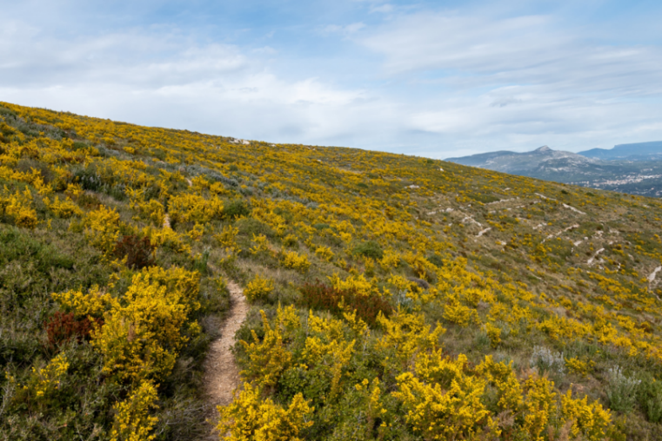
Figure 26 - Shrublands
While these figures represent national totals, Korça’s municipalities, particularly Kolonjë (Ersekë), Devoll, and Pustec, contain significant portions of these ecosystems. Their forests contribute to regional carbon storage, biodiversity, and ecological resilience. They also create microclimates that support agriculture, reduce temperature extremes, and protect water resources.

8.2 Pastures: The living carbon sinks
Pastures and meadows in Albania cover approximately 400,000–500,000 hectares, concentrated in mountainous and hilly zones. In the Korça Region, Kolonjë (Ersekë) stands out as one of the most important pasture areas, historically used for grazing sheep, goats, and cattle.

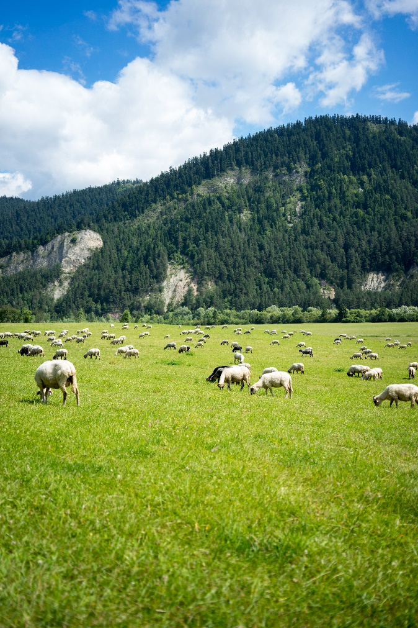
Figure 27 – Pastures

Pastures play a unique role in the carbon cycle:
- Soil‑based carbon storage
Unlike forests, where carbon is stored mainly in woody biomass, pastures store carbon primarily in soil organic matter. Perennial grasses and deep root systems continuously deposit carbon underground, creating stable carbon pools that can persist for long periods.
- Rapid regeneration
Pastures regenerate quickly after grazing. This continuous cycle of growth, grazing, and regrowth maintains constant biomass turnover, which enhances carbon fixation and supports soil health.
- Biodiversity support
Pastures host a wide range of plant species like grasses, herbs, and wildflowers, that contribute to ecological diversity. This biodiversity improves soil structure, water retention, and long‑term carbon retention.
- Climate resilience
Pastures are highly resilient to drought and temperature fluctuations. Their deep roots allow them to survive harsh conditions, making them reliable carbon sinks even in challenging climates.
Because of these characteristics, pastures are essential for regenerative agriculture, carbon farming, and climate mitigation. They complement forests by storing carbon underground, while forests store carbon above ground.

8.3 Why forests and pastures matter for Korça’s future?
Together, forests and pastures complement the region’s agricultural systems in powerful ways. Forests provide long‑term, stable carbon storage, anchoring carbon in woody biomass and deep soil layers. Pastures provide dynamic, soil‑based carbon accumulation, regenerating quickly and maintaining continuous carbon fixation. Agricultural fields provide annual biomass production, absorbing CO₂ through crops and generating residues that can be used for bio‑materials. This combination creates a landscape with high ecological potential, capable of supporting:
- Carbon farming — measurable carbon sequestration through crops, soils, and perennial vegetation.
- Regenerative agriculture — practices that restore soil health, increase biodiversity, and enhance carbon storage.
- Bio‑based material production — using agricultural residues and natural fibers for sustainable construction materials.
- Circular economy practices — transforming biomass into valuable products instead of waste.
- Climate‑resilient land management — integrating forests, pastures, and crops into a cohesive ecological system.
The Korça Region’s natural ecosystems are therefore not just background scenery, they are active contributors to the region’s environmental performance, agricultural productivity, and future development pathways. They form the foundation upon which Korça can build carbon‑positive industries, sustainable land practices, and bio‑material value chains.

9. Regional Interpretation & Synthesis

The Korça Region emerges as one of Albania’s most structurally diverse and ecologically significant territories. Its agricultural systems, natural ecosystems, and biomass flows interact in a way that creates a landscape with exceptionally high carbon‑storage potential, strong biomass productivity, and promising foundations for future bio‑based industries. The region’s geography, stretching from fertile plains to elevated plateaus and forested mountain foothills, shapes a dynamic environment where cultivation, ecology, and climate processes reinforce one another.
Across the region, the interplay between cereal‑dominated plains, forage‑rich plateaus, mixed crop basins, mountain pastures, and forest ecosystems forms a coherent environmental mosaic. Each municipality contributes differently: Korçë and Maliq provide large cereal surfaces; Ersekë and Devoll anchor forage‑based systems; Pogradec and Pustec introduce legume and vegetable diversity; and the surrounding forests and pastures stabilize the ecological balance. Together, these elements create a region capable of supporting regenerative agriculture, circular economy practices, and carbon‑removal value chains aligned with emerging European frameworks such as the EU Carbon Removal Certification Framework (CRCF).

A Region Defined by Biomass and Carbon Fixation
The agricultural municipalities: Korçë, Ersekë, Maliq, Pogradec, Devoll, and Pustec, collectively cultivate tens of thousands of hectares of cereals, forage crops, legumes, vegetables, and industrial crops. These fields act as annual carbon sinks, absorbing CO₂ through photosynthesis and storing it in biomass and soil. The region’s agricultural identity is shaped by several key crop groups:
Cereals
Cereals such as wheat, corn, barley, and rye dominate the region’s agricultural identity. They cover the largest surfaces and generate substantial quantities of straw and stalk biomass. Wheat and barley contribute large volumes of residues suitable for bio‑materials, while rye adds cold‑resistant diversity.
Corn (C4 plant)
Corn stands out for its high photosynthetic efficiency, rapid biomass accumulation, and strong carbon‑fixation capacity. As a C4 plant, corn absorbs CO₂ more efficiently than C3 cereals, making it one of the region’s most important carbon‑rich crops.
Sugar beet
Although limited in area, sugar beet contributes significantly through root biomass, storing carbon deep in the soil. Its pulp is also a valuable feedstock for bio‑materials and bio‑based composites.
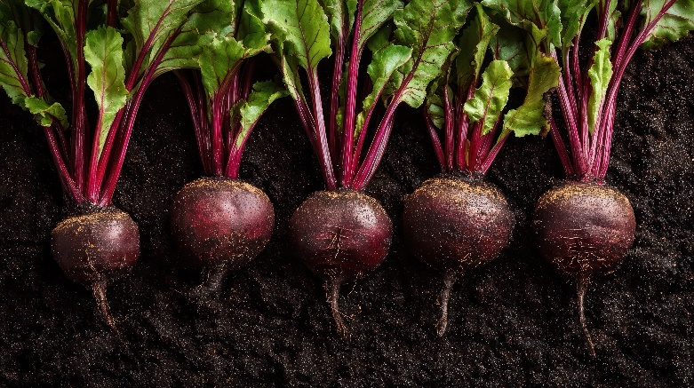
Figure 28- Sugar beet
Forage crops
Forage crops, especially in Ersekë, Maliq, and Devoll, provide continuous biomass turnover and deep soil carbon storage. Perennial grasses and alfalfa regenerate quickly, accumulate organic matter, and support livestock systems.
Legumes
Legumes in Pogradec and Pustec enrich soil nitrogen, indirectly supporting carbon retention. Beans and other legumes improve soil fertility, reduce the need for synthetic fertilizers, and contribute to regenerative agriculture.
Alfalfa
Alfalfa, present across all municipalities, adds perennial root systems that stabilize soil carbon. Its deep roots enhance soil structure, water retention, and long‑term carbon storage.
Together, these crops create a region where biomass is abundant, carbon fixation is continuous, and agricultural residues like straw, stalks, forage biomass, beet pulp, legume stalks, form a substantial resource base for future bio‑material production.

Forests and Pastures: The Ecological Backbone
Surrounding and interwoven with the agricultural zones are forests and pastures that act as long‑term ecological carbon reservoirs. These ecosystems are essential for climate regulation, soil protection, biodiversity, and water stability.
Broadleaf forests
Broadleaf forests contribute the most to seasonal carbon sequestration due to their large biomass and extensive leaf area. Oaks, beeches, and chestnuts absorb large quantities of CO₂ during the growing season and deposit organic matter into the soil.
Coniferous forests
Coniferous forests absorb carbon year‑round, stabilizing the regional carbon cycle. Their evergreen foliage ensures continuous photosynthesis, even in colder months.
Shrublands
Shrublands store carbon in soil and roots, protecting landscapes from erosion. Their dense root systems stabilize slopes and maintain soil carbon even under harsh climatic conditions.
Pastures
Pastures, especially in Kolonjë (Ersekë), function as soil‑based carbon sinks, regenerating quickly after grazing and maintaining continuous organic matter turnover. Perennial grasses deposit carbon underground, creating stable carbon pools.
These ecosystems complement agricultural carbon fixation, creating a multi‑layered carbon landscape where annual crops, perennial grasses, and long‑lived forests work together. This ecological diversity strengthens the region’s resilience to climate change and supports sustainable land management.

10. A Region Positioned for Bio‑Based Materials and Circular Economy
Although the Korça Region does not yet cultivate hemp, bamboo, Paulownia, or industrial wood forests, crops commonly associated with bio‑building materials, it possesses large quantities of agricultural residues and strong ecological foundations that can support new value chains.
Potential biomass sources include:
- Cereal straw (Korçë, Maliq, Devoll)
- Forage biomass (Ersekë, Maliq, Devoll)
- Beet pulp (Korçë, Maliq, Pustec)
- Legume stalks (Pogradec, Pustec)
- Vegetable residues (Pustec)
These materials can be used for:
- Bio‑insulation
- Straw‑based panels
- Agricultural fiber composites
- Biodegradable packaging
- Bio‑binders and bio‑resins
The region’s agricultural scale, combined with its ecological diversity, positions it well for pilot projects, processing facilities, and innovation hubs focused on bio‑materials and regenerative land management. Korça’s biomass streams could support small‑scale factories, cooperative processing centers, or regional bio‑material clusters. Korça’s agricultural landscape produces substantial amounts of carbon‑rich biomass from cereals, forage crops, legumes, and sugar beet, making it an ideal source for bio‑based construction materials that store carbon over long periods. As these crops grow, they naturally absorb CO₂ from the atmosphere, and this carbon remains locked in their residues, straw, stalks, beet pulp, and wool, when these materials are used in building applications. In Albania, several of these materials are already part of real construction practices: wood and wood‑fiber insulation are used in eco‑renovations and energy‑efficient homes; sheep wool insulation is applied in mountain guesthouses and rural cabins; straw‑clay (qerpiç) continues to be used in traditional and restored buildings; and small straw‑bale structures appear in eco‑tourism and agricultural settings. These materials not only replace high‑emission construction products like concrete and steel but also retain biogenic carbon inside buildings for decades, contributing directly to climate‑positive construction. With its continuous supply of biomass and diverse crop base, Korça is well‑positioned to expand the use of carbon‑storing construction materials and become a regional driver of sustainable, low‑emission building practices.

10.1 Alignment with Carbon Removal Certification Framework (CRCF)
The Korça Region’s agricultural and ecological characteristics align naturally with the principles of the EU Carbon Removal Certification Framework, which emphasizes:
- Measurable carbon sequestration
- Long‑term storage
- Sustainable land management
- Traceable biomass flows
- Regenerative agricultural practices
Municipalities like Ersekë and Maliq, with their extensive forage systems and large cereal surfaces, are particularly suitable for CRCF‑aligned carbon farming. Forested and pasture areas in Devoll, Ersekë, and Pustec further strengthen the region’s potential for certified carbon removal.
CRCF could support Korça in developing:
- Carbon‑credit markets
- Verified carbon farming programs
- Biomass‑based carbon storage projects
- Long‑term ecological monitoring systems
A Landscape Ready for Regenerative Transition
Taken together, the Korça Region presents a landscape where:
- Agriculture is productive and diverse, offering multiple biomass streams.
- Biomass is abundant and continuous, supporting bio‑material industries.
- Carbon fixation occurs across multiple ecosystems, from crops to forests.
- Natural and cultivated systems complement each other, creating ecological balance.
- Future bio‑based industries can be rooted in existing resources, without requiring major land‑use changes.
This makes Korça not only an agricultural region, but a strategic territory for Albania’s transition toward circular economy practices, sustainable construction materials, and regenerative agriculture. The region’s combination of ecological diversity, agricultural productivity, and biomass availability positions it as a potential leader in Albania’s green transformation.

10.2 EU policy and regulatory framework
The development of agro-building and carbon-storage solutions is increasingly supported by the European Union's transition towards a climate-neutral, circular and resource-efficient economy. Although the term “agro-building” is not itself an EU legal category, its principles are directly connected with several major EU policy areas, including carbon farming, carbon removals, the bioeconomy, sustainable construction, energy performance of buildings, circular economy and the Common Agricultural Policy.
A particularly important recent development is Regulation (EU) 2024/3012 establishing the EU Carbon Removal Certification Framework (CRCF). The Regulation creates a voluntary EU-wide framework for certifying permanent carbon removals, carbon farming and carbon storage in products. Importantly for agro-building, the framework explicitly recognizes carbon storage in long-lasting products for at least 35 years, including wood-based construction products. The Regulation therefore establishes an important policy bridge between agricultural and forestry production and the construction sector.
The relevance of the CRCF to agro-building is particularly strong because agricultural and forestry biomass can be transformed into construction products capable of retaining biogenic carbon over long periods. The European Commission identifies bio-based construction products, including timber and products derived from agricultural crops, as having potential to store carbon absorbed during plant growth throughout the useful life of the material. The Commission is also developing certification methodologies for carbon storage in products and indicates that a methodology for buildings is planned, which could allow the carbon-storage performance of buildings to be demonstrated more systematically.
The CRCF is based on four fundamental principles: quantification, additionality, long-term storage and sustainability. Certified activities must demonstrate a quantified net carbon benefit, go beyond what is legally required, maintain carbon storage over the relevant period and avoid significant environmental harm. These principles are highly relevant for future Albanian agro-building initiatives, particularly if such initiatives aim to develop credible carbon claims, environmental labels or eventually participate in EU-related carbon markets.
The EU framework also increasingly links carbon farming with biomass production and the bioeconomy. The Commission's 2026 certification methodologies cover agriculture and agroforestry on mineral soils, peatland and organic-soil restoration, and afforestation. These developments strengthen the policy relationship between sustainable agricultural land management, biomass production, carbon sequestration and downstream bio-based applications.
A second major policy area is the Energy Performance of Buildings Directive (EPBD). The revised approach to building performance increasingly considers not only operational energy consumption but also the wider environmental performance of buildings and their life cycle. The European Commission has specifically identified whole-life greenhouse-gas assessment and the carbon-storage capacity of buildings as important elements of the future building framework. This creates opportunities for construction approaches using locally sourced timber, agricultural fibers, straw, hemp, cork, wood residues and other renewable biological materials, provided that technical, safety and durability requirements are fulfilled.
The EU Construction Products Regulation (CPR) is also important. The revised regulatory framework aims to facilitate the circulation of construction products while promoting circularity, innovation and better environmental information. It foresees improved information for consumers and digital product passports, while the European Commission is supporting standardization for bio-based construction products. This is particularly relevant to agro-building because agricultural residues and biomass cannot become mainstream construction materials simply through their carbon-storage potential; they must also demonstrate appropriate structural, fire, health, durability and other performance characteristics.
At the strategic level, agro-building is therefore aligned with the European Green Deal, the EU Climate Law, the Circular Economy Action Plan, the EU Bioeconomy Strategy, the Common Agricultural Policy 2023–2027, and EU objectives for climate neutrality by 2050. Collectively, these policies encourage the transition from a linear model produce, consume and dispose towards systems in which agricultural and forestry resources are maintained in productive cycles and biomass residues become valuable inputs for new products and services.

10.3 Regional and national context in Albania
For Albania, the EU framework is particularly relevant because the country is a candidate country and is progressively aligning its legislation and sectoral policies with the EU acquis. Consequently, the development of agro-building should be considered not as an isolated construction innovation but as a cross-sectoral opportunity connecting climate policy, agriculture, forestry, construction, energy efficiency, waste management, rural development and circular economy.
Albania has already established important elements of the legal framework necessary for this transition. The country's legislation on energy efficiency and energy performance of buildings has been developed in substantial alignment with EU legislation. The Law on Energy Efficiency (No. 124/2015) transposed key elements of EU energy-efficiency legislation, while the Law on Energy Performance of Buildings (No. 116/2016) established requirements for improving building energy performance and incorporated the concept of nearly-zero-energy buildings.
The Albanian policy framework is also increasingly oriented towards decarbonization. The National Energy and Climate Plan (NECP) 2020–2030, approved by Decision of the Council of Ministers No. 872 of 29 December 2021, establishes an integrated framework for energy and climate policy and includes objectives concerning greenhouse-gas reduction, renewable energy and energy efficiency. The plan is being revised to respond to updated Energy Community objectives for 2030. Albania is in an excellent position in relation to the Green Deal, with an energy sector based almost entirely on hydropower plants that produce clean energy, but it is often exposed to shortages in dry years. Albania aims for a 15.5% reduction in energy consumption and is making efforts to achieve the EU target of 87% by 2030. Renewable energy, especially from sources other than hydropower, is a solution for issues related to energy production and climate change mitigation. The challenge for water management in relation to the environment is to balance the needs of diverse ecosystems with the needs of other water users. Protected areas, wetlands and forests are the three main habitats considered to directly affect and be affected by water. Protected areas have increased because of reviews of their boundaries, the declaration of new protected areas and the expansion of existing ones. Albania is one of the countries with the lowest levels of greenhouse gas (GHG) emissions in the region, but, at the same time, it is the most vulnerable to the effects of climate change due to natural disasters. The NDC document sets out measures for mitigation and adaptation. National legislation on ambient air quality has been aligned with that of the EU at an advanced level, but air-quality-monitoring practices need to comply with EU standards. Increased investment is needed to ensure continuous monitoring, data provision and reporting on air emissions from all contributing sectors
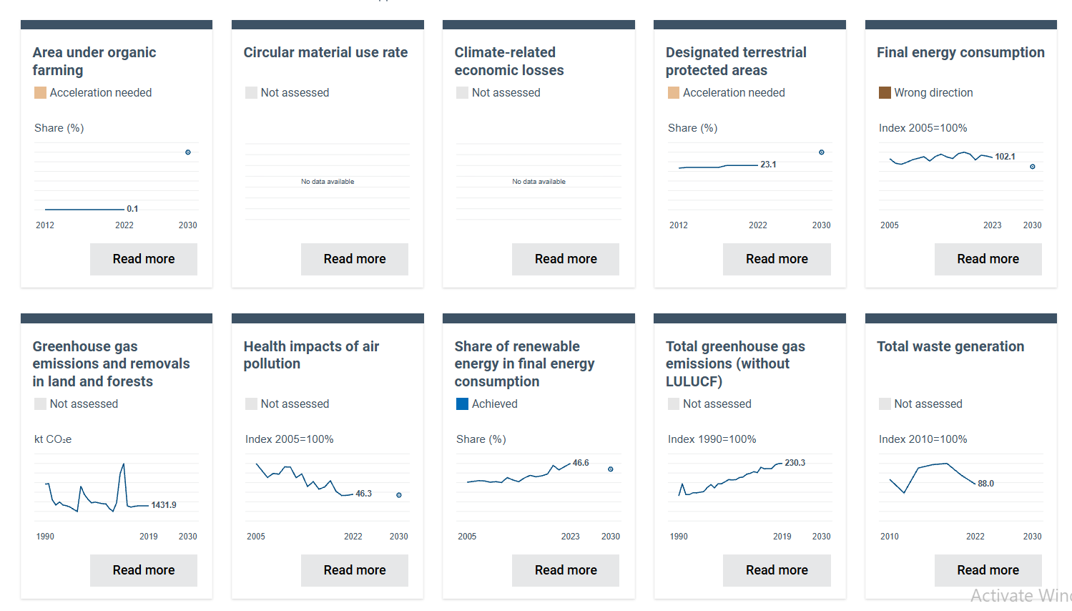
Figure 29 – Country benchmark towards 2030 objectives
The building sector is consequently an important area for climate mitigation. Recent Albanian policy work concerning the energy performance of buildings aims at improving the energy performance of the building stock and reducing greenhouse-gas emissions, with a longer-term objective of achieving a zero-emission building stock by 2050. This provides a favorable policy environment for solutions that combine energy efficiency with low-carbon and carbon-storing construction materials.
The agricultural dimension is supported by the Strategy for Agriculture, Rural Development and Fisheries 2021–2027, approved by VKM No. 460 of 29 June 2022. The strategy promotes a competitive, sustainable and innovative agri-food sector and includes priorities related to sustainable management of natural resources, climate measures, biodiversity, efficient use of agricultural inputs and innovation.
This strategy is particularly relevant to agro-building because it provides a policy basis for investigating how agricultural production can generate additional value through biomass residues, by-products, sustainable land management and new rural value chains. The use of agricultural residues as construction inputs could simultaneously address waste/resource-efficiency challenges, create additional income opportunities for farmers and reduce dependence on carbon-intensive conventional construction materials.
The National Strategy for Agrotourism, presented in 2023, is another relevant policy instrument. It promotes sustainable development of agrotourism, stronger short food supply chains and the valorization of traditional rural products and local identity. In this context, agro-building could provide an innovative dimension to rural tourism through the development of low-carbon farm accommodation, visitor centres, rural facilities and demonstration buildings using locally available bio-based materials.
At the territorial level, the National Strategy for Development and Integration establishes sustainable resource use and territorial development as a strategic pillar and explicitly connects urban, rural and regional development with sustainable territorial planning. This creates a policy basis for integrating agro-building initiatives into regional and local development strategies, particularly in areas where agriculture, forestry, tourism and construction interact.

10.4 Implications and policy gap for Albania
Despite this favorable policy environment, an important regulatory and institutional gap remains. Albania does not yet appear to have a dedicated legal framework defining “agro-building” or establishing specific procedures for recognizing and certifying the carbon stored in agricultural or forestry-based construction materials. Existing legislation regulates the component sectors agriculture, construction, energy performance, forestry, environmental protection and waste/resource management but does not yet fully connect them through a dedicated carbon-storage value chain.
At the end the policy analysis indicates that Albania already possesses many of the enabling elements for agro-building and carbon-storage development, but these elements remain fragmented across different sectors. The main opportunity for the Quick Scan is therefore to identify how the existing EU-oriented climate, energy, agricultural, construction and rural-development frameworks can be connected into an integrated “farm-to-building” carbon value chain. Such an approach would allow agricultural and forestry biomass to be considered not only as a primary production resource or waste stream, but also as a potential source of renewable construction materials, long-term carbon storage, rural economic diversification and climate mitigation.
For the Albanian context, this means that agro-building should initially be promoted through pilot projects, technical standards, carbon-accounting methodologies and voluntary certification, while simultaneously assessing the need for future amendments to national regulations. The emerging EU framework particularly the CRCF and the increasing recognition of bio-based construction products provides a useful reference point for designing an Albanian approach that is compatible with the country's EU integration trajectory.

11. Mapping of existing projects and initiatives.
Agro-building and carbon-storage initiatives are important for Albania because they connect two sectors that are fundamental to citizens' everyday lives: agriculture and housing/construction. Albania's agricultural and rural economy remains highly significant, while national policy is increasingly focused on climate resilience, sustainable resource use and EU integration. The quick scan identifies some of the existing projects respectively:

11.1 AWeS0Me – Agricultural Waste as Sustainable 0 km Building Material
AWeS0Me is another highly relevant Albanian initiative, although its primary emphasis is on agricultural-waste-based building materials and energy efficiency, rather than carbon-removal certification.
The project was implemented under the Interreg IPA CBC Italy–Albania–Montenegro Programme. Its objective was to promote sustainable construction materials made from agricultural waste, particularly bio-based building components with good hygrothermal performance. It included pilot laboratories and demonstration of technical solutions compatible with EU energy criteria.
This is important because it provides an earlier example of the “agricultural waste → building material” value chain in the Albanian/Adriatic context.
The project specifically sought to:
- raise awareness about construction materials produced from agricultural waste
- develop bio-based building components
- improve thermal insulation
- reduce the environmental impact of construction
- test bio-based construction solutions
- build a knowledge network involving public administrations and other stakeholders.
Therefore, AWeS0Me can be considered an important precursor initiative to the current ABC approach.
Figure 30 - AWeS0Me project website
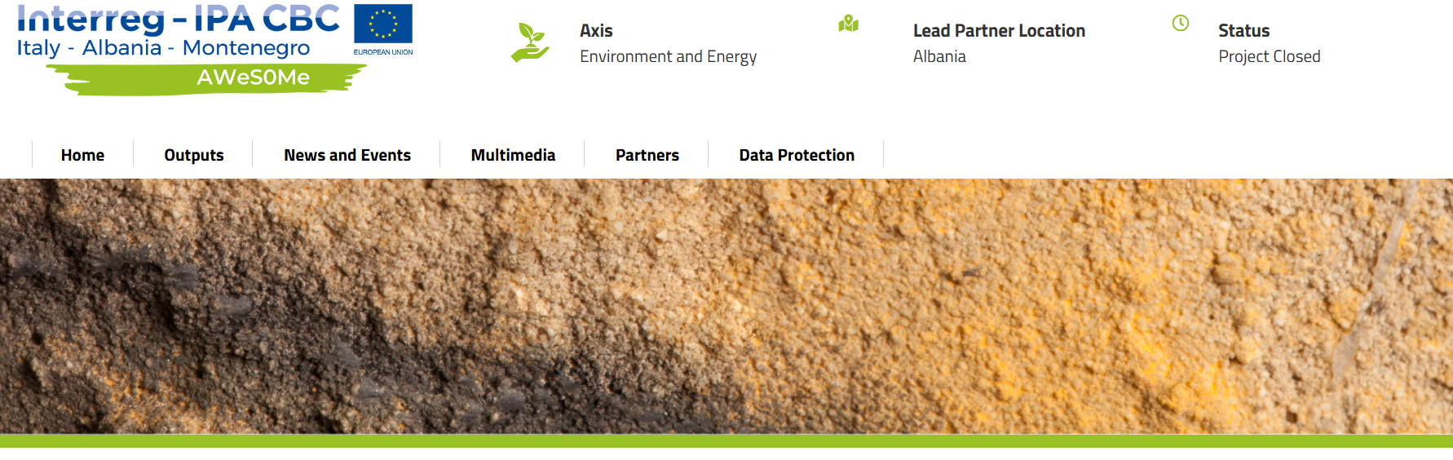

11.2 AWeS0Me PLUS – Agricultural Waste as Sustainable 0 km Building Material Plus
There is also a follow-up initiative, AWeS0Me PLUS, under the Interreg IPA South Adriatic 2021–2027 programme.
The project specifically aims to capitalize on the results of AWeS0Me and promote the use and development of green thermal-insulating materials obtained from agricultural waste to improve building insulation. It has a relatively small budget (€65,615) and focuses on the South Adriatic area.
This is particularly interesting for the Quick Scan because it demonstrates that the agricultural-waste/building-material concept has moved from a previous project into a capitalisation and continuation phase.
However, it should be distinguished from ABC: AWeS0Me PLUS focuses primarily on energy efficiency and thermal insulation, whereas ABC explicitly introduces carbon storage/carbon removal as a policy objective.

11.3. Biochar initiative in Albania – P.L.A.N.T. Foundation
A more recent initiative is being developed by the P.L.A.N.T. Foundation in Albania around an inverted-cone biochar kiln.
The initiative started in 2026 and involves an MoU with Agro-Re-Generations Ltd. It aims to pilot a technology for converting agricultural residues into biochar, replacing open field burning. The stated KPIs include biochar production, soil-quality improvement, carbon sequestration and the number of Albanian pilots launched.
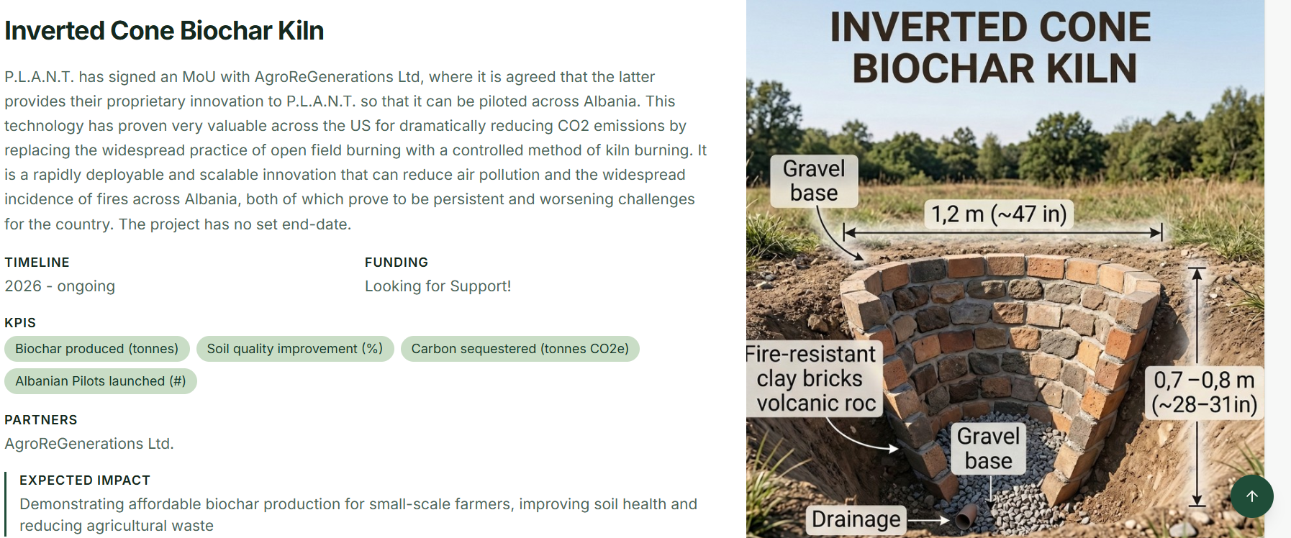
Figure 31 – Biochar Initiative
This is not agro-building in the strict sense, because the biochar is intended primarily for agricultural soil applications rather than construction materials. Nevertheless, it is highly relevant to the broader agricultural biomass → carbon storage ecosystem.
It could become relevant to agro-building if future applications include biochar-based insulation, bio-composite panels, concrete additives or other construction products.

12. Conclusions
The landscape of Korça Region reveals a territory where agriculture, ecology, and biomass production intersect in meaningful and strategic ways. Each municipality contributes a distinct layer to the region’s identity: Korçë with its cereal plains, Ersekë with its forage‑rich plateaus, Maliq with its expansive agricultural surfaces, Pogradec with its mixed and legume‑intensive systems, Devoll with its balanced cereal‑forage structure, and Pustec with its small but diverse cultivation patterns.
Together, these municipalities form a region capable of supporting carbon‑rich biomass flows, regenerative agricultural practices, and emerging bio‑based material value chains. The agricultural systems absorb CO₂ annually through photosynthesis, while forests and pastures provide long‑term ecological carbon storage. This multi‑layered carbon landscape positions Korça as a territory with both environmental significance and economic potential.
Although crops traditionally associated with bio‑building materials, such as hemp, bamboo, and Paulownia, are not yet cultivated, the region’s existing biomass (cereal straw, forage residues, beet pulp, legume stalks, vegetable waste) offers a strong foundation for pilot projects and innovation hubs. These materials can be transformed into insulation, fiber panels, composites, and biodegradable products, supporting Albania’s transition toward circular economy practices and sustainable construction.
The Korça Region’s agricultural diversity, ecological resilience, and biomass availability align naturally with the principles of the EU Carbon Removal Certification Framework (CRCF). With proper monitoring, certification, and value‑chain development, Korça can become a model region for carbon farming, bio‑material production, and regenerative land management.
In summary, Korça is not only an agricultural region, but also a landscape with the capacity to evolve into a strategic hub for carbon‑removal initiatives, sustainable construction materials, and circular agriculture, grounded in the resources and ecosystems already present today.

12.1 Priority recommendations
Based on the quick scan, the following priorities are recommended for policy makers and stakeholders:
- Integration of agro-building and carbon-storage objectives into the revision of the Korçë Municipality Development Plan, recognizing agricultural biomass as a strategic local resource for circular construction and climate mitigation.
- Updating the Climate Mitigation Strategy to include bio-based construction materials and long-term biogenic carbon storage as complementary measures alongside energy efficiency, renewable energy and low-carbon mobility.
- Development of a local agricultural biomass/resource map identifying the main residues, their quantities, seasonality, geographical concentration, current uses and potential construction applications.
- Establishment of a pilot Agro-Building Carbon projects in Korçë, prioritizing insulation panels, fiber-based boards, lightweight construction elements and other technically feasible applications.
- Creation of a cooperation mechanisms between farmers, agro-processors, forestry operators, construction companies, architects, universities and public authorities to establish a local agro-building value chain.
- Supporting testing, certification and standardization of agro-based construction products and strengthen the capacity of Albanian laboratories and research institutions to assess their structural, thermal, fire-safety and environmental performance.
- Introducing economic incentives and green public procurement criteria favoring locally produced, recycled and bio-based construction materials with demonstrated carbon-storage potential.
- Development of a methodology for measuring and verifying carbon storage, including biomass origin, processing, product lifetime and end-of-life management, to ensure that claimed carbon benefits are credible.
- Promote awareness and capacity building among municipalities, farmers, architects, engineers, construction companies and investors concerning the technical and economic potential of agro-building materials.
- Use Korçë as a demonstration territory for replication, developing an approach that can subsequently be transferred to other Albanian regions where agricultural and forestry biomass resources are available.

Source: Korça Region Strategic Development Plan
INSTAT – Instituti i Statistikave i Shqipërisë. Agriculture, Forestry and Fishing Statistics 2024.
INSTAT – Agricultural Production by Region (Korçë Prefecture)
INSTAT – Instituti i Statistikave i Shqipërisë. Agriculture, Forestry and Fishing Statistics 2024. Ministry of Agriculture and Rural Development (MARD)
European Commission. EU Carbon Removal Certification Framework (CRCF).
European environment Agency, Country Profile, Albania

